|  |  |
| --- | --- |
|  | Kevin Richard Ruby  WRTG 3035 |

**Abstract:**

The Department of Computer Science is one of the most populated disciplines within the College of Engineering. To add to this, the computer science industry is projected to grow much faster than other industries over the next 10 years, according to the U.S. Bureau of Labor Statistics. Despite this, Computer Science students do not believe they are equipped with the necessary tools for the highest success. CS students feel undervalued compared to their counter parts within the College of Engineering.

Overcrowded classes scattered campus-wide, unqualified professors, and no common area are some of the main concerns of Computer Science students that pay a large sum of money for this degree. This paper will examine what causes these issues and provide possible solutions to them. Research has been conducted on students and faculty, with hopes these results will try to answer why the problem arises.

**The Problem**:

The Department of Computer Science does not provide its students with the correct tools to succeed.

**Students are not provided with adequate class environments to succeed**

Computer Science classrooms are scattered all across campus. Eaton Humanities, Fleming Law, and Gold Biosciences are just some of the random buildings that CS students have been crammed in. These classes are packed full, with some students sitting in the walkways. It almost feels as though the department is packed too full, because of these classes being in various locations.

**Figure 1. Student responses from ‘CS Questionnaire’**

As shown above, the majority of CS students have classes scattered across the campus. They are far from the location office hours are held. Students should have classes held in one central location, the Engineering Center. Holding classes in the Engineering Center would allow CS students to be closer to the available resources the department offers. However, moving classes closer to these resources only help if there are in fact viable resources available.

**Students are not provided with the best resources to succeed**

Computer Science is a discipline in which collaboration is essential. There are many different ways for this to happen:

* Student to Student/Group
* Student to TA
* Student to Professor

**Figure 2. Student responses from ‘CS Questionnaire’.**

As seen above, it is obvious the department has failed to provide an adequate common area for CS students and faculty. The departments common space, known as CSEL, was a small, smelly area. It was filled with beaten down couches and tables, with a couple of random rooms in stuffed in the corners. CSEL was always packed full, with multiple classes holding their office hours at a time. During peak hours, there could be up to 3 different courses office hours being held at just one table. Students and TA’s end up laying on the carpet attempting to review material. Below are some results from ‘CS Questionnaire’:

**Figure 3. Student responses from ‘CS Questionnaire’.**

**1 = ‘hated it’**

**5 = ‘loved it’**

The data shows students did not feel CSEL was an adequate place to gather and collaborate. Then came the Leeds-Engineering expansion project. The entire Computer Science wing was to be closed for the foreseeable future. Below is a picture of the old CS wing:

**The Computer Science wing is highlighted in the lighter gray. CSEL was a small portion within this wing. Red Hashes show the entire wing is closed to construction.**

With hopes we would finally receive a new space, there was an encouraging feeling of hope around the department. However, this feeling was quickly destroyed. The students were moved to the old aerospace wing. This wing contains some leftovers the program didn’t want to bring to their new 82.5 million dollar mega-building. We are left with a few tables and one couch, with a very small, around 30 square foot, “CSEL++”. I personally have been to office hours in there, and I end up standing with my professor attempting to find solutions.

CS students were basically just forced there, and there have been no attempts to improve this space or design it based on the specific needs a CS student. With CSEL and the ‘new’ CSEL++, the department has failed to supplement students with an adequate common space to advance their learning. The fact is, students are not provided with the best resources to succeed

**Students are not provided with the best professors to succeed**

To advance in life and make an honest living, college is essential. Society paints this picture: if you want a high paying job, you need to get a high-level education. Students and their families pay a lot of money for this high-level education. In return, they expect education that connects the students to the best professors for the job.

Unfortunately, students are not provided with the best professors to succeed. In fact, some aren’t qualified professors at all:

***“Throughout my years I’ve had many unqualified instructors, many were masters students.”***

***“I took a class and the 'professor' was a graduate student who admitted he was a student in this class a few years back”***

***CU Boulder student’s response to: Biggest complaint of the department?***

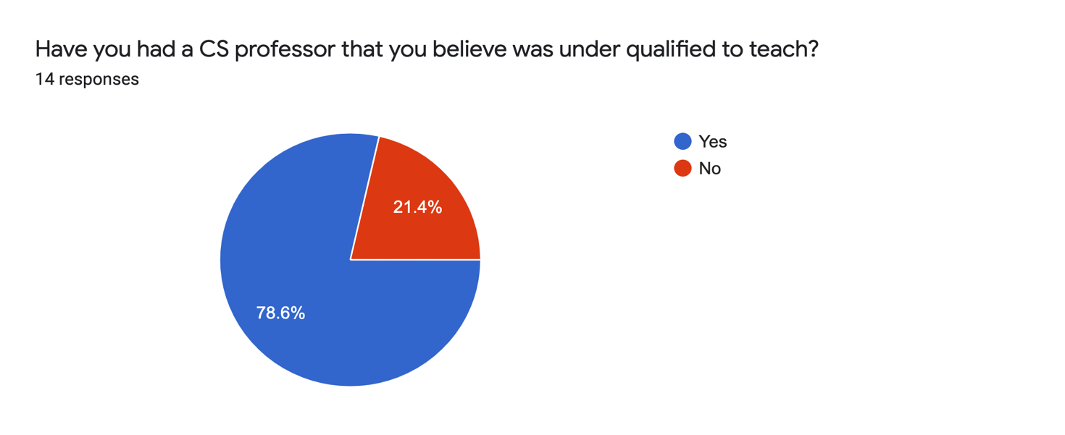

**Response from ‘CS Questionnaire’**

The results of the questionnaire are obvious, Computer Science students feel the University does not provide them with the necessary instruction in order to succeed at a high level. This begs the question: *Are graduate students qualified enough to be the primary instructor?*

There has been a plethora of research done on this topic. There are some benefits, including easier connections between undergraduate and graduate. However, there also many negatives. Here is a quote taken from InsideHigerED:

***“…most recently Purdue University -- have taken steps toward limiting the use of graduate students as instructors.”***

***[1]***

Colleges are finding the negatives in graduate students in primary teaching roles. David Reingold, the S. Morrill Dean of the College of Liberal Arts at Purdue University is at the head of this initiative, thanks to the complaints of several students at Perdue. He is limiting this in an attempt to connect new college students to faculty members and increase the university’s reputation. New students need powerful and knowledgeable instruction in their early years of college, and grad students simply don’t provide this:

***“… But their knowledge and teaching skills are rarely equivalent to the faculty members' expertise and teaching abilities.”***

***[1]***

Personally, I have had many scholarly interactions with graduate and masters students in this discipline. I believe they are great in the assistant roles to the course, TA’s and LA’s. They are more relatable and easier to talk to in my experience. However, I do not approve them to be a primary instructor, especially in the Foundation CS classes that we are required to take. The Department of Computer Science should be able to provide students with the highest quality of professors they can find, and the fact they don’t is one of the problems with this discipline.

**The Real Problem**:

After looking at the data from my survey sent out to students, I achieved my goal of proving these problems are department wide, most students in this discipline are faced with the struggles I have listed above. “Why do we feel this way” I kept asking myself. It became obvious I was not equipped to answer this question, so it was necessary to get answers from the faculty ‘responsible’ for our problems.

After much conversation, I evolved the problem:

The University does not provide the Department of Computer Science, and thus its students, with the correct tools to succeed.

My research brought an opportunity to ask a new question: Why is the Department of Computer Science at the least of the Universities priorities? But before we answer this, a little background needs to be explained.

**B.A. vs B.S.**

The University of Colorado actually offers two versions of the Computer Science degree. One through the College of Engineering (BS), and one through the College of Arts and Sciences (BA). These degrees consist of generally the same courses, with some variance in electives and math requirements.

**BA (left) vs BS (right) Computer Science foundational courses.**

My research proceeded with Ken Anderson and Claire Colvin, both faculty in the Department of Computer Science. I asked them to explain the differences between the two degrees. Below are their responses:

***The CS-BS is more technical in nature, offers fewer electives outside the discipline and provides an opportunity to go deeper into the field of computer science. It is also ABET accredited.***

***Claire Colvin – Assistant Director of group overseeing transfer***

***The BA degree provides access to a more rounded liberal arts education and encourages students to be interdisciplinary.***

***Ken Anderson - Chair, Department of Computer Science***

The B.A. degree began in 2013, due to the up rise of computer science majors demanded by tech companies. The university wanted to provide a computer science option who were not accepted into the College of Engineering. Since then, it has grown to house more than 1100 students, which is one of the largest majors on campus.

According to Ken Anderson, who created and has overseen this major since 2010, CS-BA has been an amazing addition to the university, mass producing the highly demanded computer science students. However, the creation also came with some unforeseen consequences.

**The money issue: B.A vs B.S.**

This section will examine the root of all these problems: money. In the above section, we can see that BA and BS students take a majority of the same classes. Lesley McDowell, Advisor of Computer Science provided me with the information that every single class listed above in instructed through professors (qualified professors, we hope) that belong in the College of Engineering. Of course, these professors are paid through the Engineering School’s budget. Seem unfair? Students who belong to the College of Arts and Science are fiending off the professors thought only to teach engineering students. This behavior is a fault in the Universities budget system. Allow me to explain how I interpreted this budget system:

* Budgets at CU Boulder are based on the departments head count,
* Money is rarely shared between colleges, meaning the College of Arts and Science and the College of Engineering did not have a flow of money between the two, even though the flow of students taking college-specific courses exists.

The budget system is odd and does not account for all necessary factors. Anderson shared the following with me:

***“most of the expenses for the degree (salary; instructional resources, etc.) were being accrued in Engineering but most of the revenue was going to A&S”***

It is simple - Engineering pays for professors and resources in common areas (or lack thereof), while BA students use these features and pay their fees to College of Arts and Science.

After my research, it is clear that the Department of Computer Science does not play a hand in the table of all the listed problems. It is in fact stemming from even above them in the rankings: The University. The students are faced with various problems, but this is because the Department is faced with problems of their own. The University was finally made aware that their budgeting system was having negative effects on the department, and thus the students.

**The Solution: Combine the two (sort of)**

Abolish the BA program and keep Computer Science in the College of Engineering. This is how I interpreted the change the university is planning to implement in Summer 2020.

However, during my research, Ken Anderson made it clear:

***Absolutely not! I invested three years of my life getting it created and it’s only been in effect for just shy of seven years. Degree programs last for decades!***

***Ken Anderson, in response to “is CU eliminating this BA degree entirely?”***

The university has made the decision to keep both the BA and the BS, however, now they will both be offered through the College of Engineering. By offering both through the same college, the university plans to fix this budget issue. The expenses will still arise from the College of Engineering, but now the revenues of ALL Computer Science students, BS and BA alike, will also flow through Engineering School.

**The Solution: Will it Work?**

I personally have full confidence that this should solve most of the problems outlined in this paper. To review, our initial problems were stated as:

* Poor class environments and locations
* Faculty not qualified to instruct students
* Students not provided with proper resources (office hours locations, common areas)

I believe the latter two of these problems are caused by the money issue previously stated. The department will have sufficient funds to hire real professors to teach our classes, thanks to the merge of the programs. Professors with qualifications that are capable of teaching 300+ students per lecture. With the increased cash flow, it is expectedthere will be major upgrades to CSEL, with newer spaces and more room for instructors and students to meet and collaborate.

However, this increased cash flow does not solve the issue of classes being scattered.

After conversation, the fact is there are just too many students in this amazing program, with not enough classrooms solely in the Engineering Center. Computer Science degree is one of the most sought-after disciplines companies are searching for. The number of students is only going to grow, and they bring more money with them. We can only hope, someday, the University will use this cash and provide CS students with a building of their own, full of high tech classrooms and plenty of room for students to experiment with new techniques that will allow them to bloom into the most productive version of themselves.

**Conclusion:**

This White Paper was written to examine the problems within the Department of Computer Science here at CU Boulder. These problems were stated as: poor class environments and locations,faculty not qualified to instruct students, andstudents not provided with proper resources. After surveys with students alike, these problems were proven to exist through the entire department. Further research was needed to understand why these problems exist, so attention was turned to faculty within the department. Responses from them allowed me to shift the blame of our problems, from the department to the university. The root of the problems is simply due to money, or lack of it. The university has an odd budget system, and due to the fact two CS degrees are offered, money was not flowing as fluidly as the university had planned. Effective Summer 2020, a new plan is implemented to attempt to fix this money issue. Only time can tell if their plan pans out, and hopefully it does for the sake of future CS students. But for now, current students will have to make deal with these problems, knowing their comments and concerns didn’t go unheard. We can only hope our actions will result in a more positive experience for the class of 2021 and beyond.

**Sources**

[1] insidehighered.com/news/2016/03/08/study-suggests-graduate-student-instructors-influence-undergraduates-major

[2] <https://forms.gle/bFuRfixVnoNwYNQs7> , form used to question students